# FRP MANUFACTURER

ENTIRE RANGE OF FIBRE GLASS WOVEN ROVING AND INSULATION MATERIAL

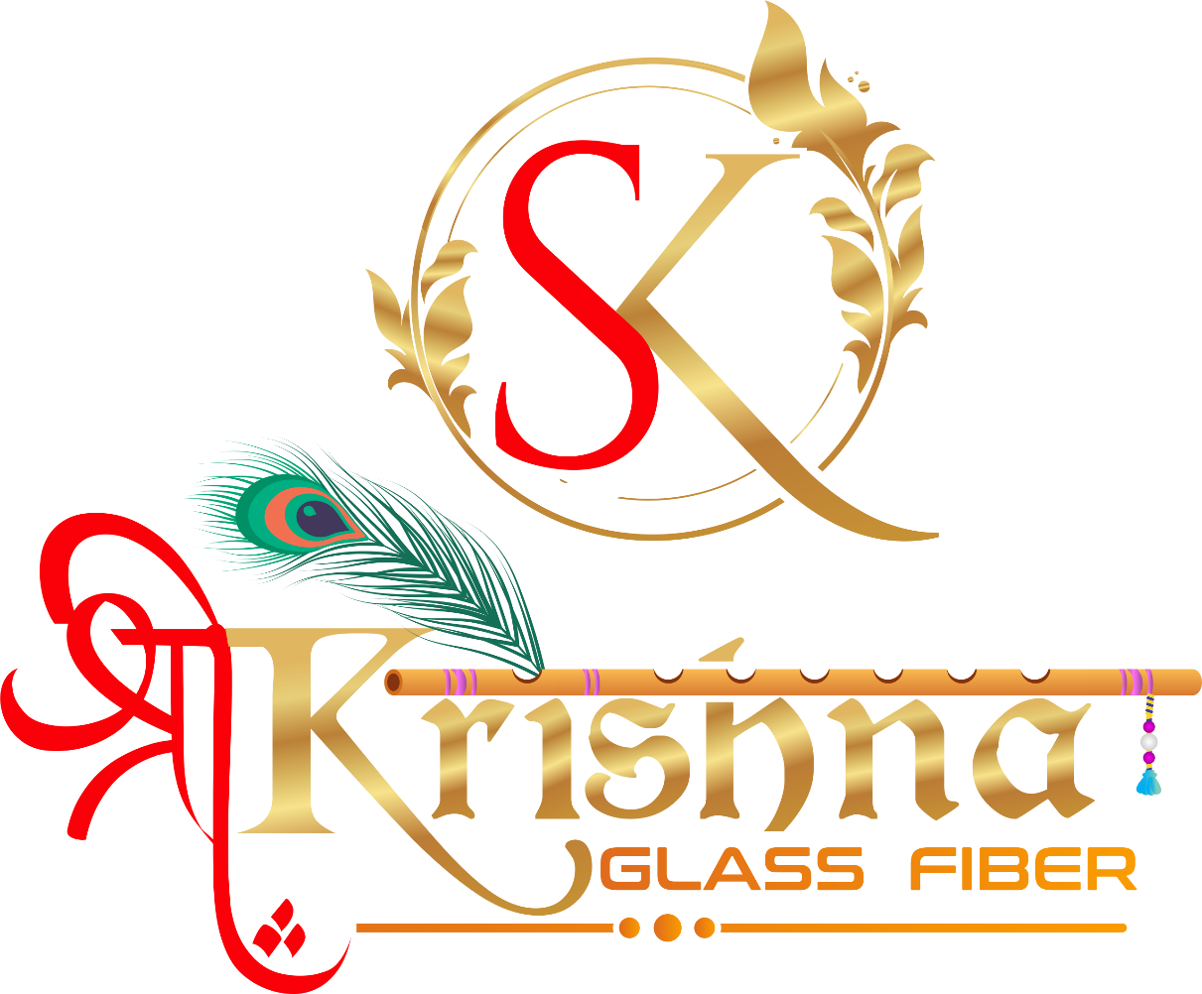

**COMPANY PROFILE**

SHREE KRISHNA GLASS FIBER is one of the leading manufacturing companies of E-GLASS OF WOVEN ROVING. Established in 2021. we have emerged as a key player in Fibre Glass insulation market.

Our products comprised of e Of E Glass roving & E Glass woven roving & Fiber Glass Pultrusion components & FRP sheets for Electrical Insulation, Thermal Insulation and other engineering applications. The Pultruded products are FRP Epoxy Rods, Tubes, Rectangular Flats, Dog bones, Corners, angles, FRP Threaded rods, Washers, Spacers, Nuts & Custom-Built sections. We also offer wide range of thermal electrical insulated products, FRP epoxy sheets, FRP polyester sheets.

We, SHREE KRISHNA GLASS FIBER, believe in accepting challenges and directing our service of excellence through well-structured system embracing philosophies of national & international quality parameters.

We also own a wide spectrum of machineries required for manufacturing Woven roving & FRP products, work force of qualified engineers, experienced supervisors / technicians and devoted skilled workers ensuring that our product is meeting customers' requirement and highly reliable with durability. We also encompass the entire test facilities to measure all parameters specified by our customers.

## **OUR VISION**

The vision of SHREE KRISHNA GLASS FIBER is a Indian manufacturer of top-quality Woven roving & FRP Products. We dedicate ourselves to be the supplier of choice when our types of products are being sought. This vision will be accomplished by sharing the responsibilities of planning and decision making with all of our employees. SHREE KRISHNA GLASS FIBER will strive to maintain the Quality and image it has developed over the years with its suppliers, employees and community as a company of excellence.

**Our Product**

1. **Woven Roving**

EWR – 610 GSM

EWR – 410 GSM

EWR – 360 GSM

EWR – 200 GSM

1. **Roving**

300 Tex

600 Tex

1200 Tex

2400 Tex

4800 Tex

1. **FRP Sheet**

* Epoxy Sheet
* Polyester Sheet

1. **Pultrusion Section**

* Dogbone
* Corner Angle
* Rod
* Tube
* Strips
* Channel

1. **FRP- Sheet Components**

* FRP – Threaded Rods
* FRP – Hexnuts
* FRP – Washer
* Step – Washers
* FRP – Block
* Busbar Support



**ADDRESS**

3B, Omkar Estate, opp. Sabarmati Gas Station, Santej - Khatraj Road, Khatraj,Ta-kalol,Dist.Gandhinager-382721

**Phone**

VIRAJ N. PATEL – 9898022566

**E-mail**

**Web**